3.02 Mushrooms: A Superfood

Background
Mushrooms are unmistakably nutritious. Aside from a plethora of nutrients, they are low in calories, full of fiber and have more protein than a kidney bean. Talk about a fungus that packs a punch. Discover all of the benefits of eating mushrooms, a “superfood” and find a recipe that entices your taste buds that includes this incredible ingredient.

Assignment
Go to the Mushroom Council’s website and find the nutritional benefits of mushrooms (http://mushroominfo.com/benefits/). There are two additional resources (an infographic and information about mushrooms in general) from the Mushroom Council. Use these resources to fill out the graphic organizer, below, about mushroom nutrition. Find the nutritional information for white button mushrooms via the Mushroom Council. Describe why that nutrient is important or give additional statistics about this nutrient.

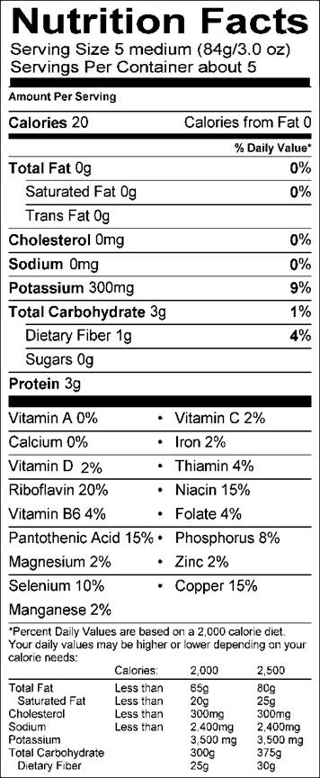
Mushrooms: Superfood Facts
Visit the Mushroom Council’s website and search for the following information about this superfood. Use mushroomcouncil.org and www.mushroomsonthemenu.com for all of the questions.
- What are the four areas that mushrooms can positively impact human health?
a.
b.
c.
d.

- How can mushrooms make a hamburger “skinny’? What is the gourmet culinary trend impacting both the beef and mushroom industry while slimming consumers’ waistlines?

- List five ways that combining mushrooms with meat dishes can be beneficial?
a.
b.
c.
d.
e.

- How many pounds of mushrooms are grown every year in the United States?

- What is the most popular variety of mushrooms?

- Now, find a mushroom recipe that you would like to try or introduce your family to. Jot down the ingredients and nutritional facts here. Write down a summary of how this delicious fungi dish is prepared.

- Which taste receptor does the mushroom ignite on people’s palate?

- What are four cooking techniques for using mushrooms in cuisine?
a.
b.
c.
d.

- When you think of mushrooms, think of:
M

U

S

H

R

O

O

M

S

- What are “Meatless Mondays” in K-12 schools around the glove?

