5.01 Microorganisms and Food Safety
Beware: fungus is amongus!

Background
Fungi is a peculiar little organism. Just after the mushroom cap has grown (the fruiting body), it releases spores that grow into microscopic hyphae and combine with other hyphae to exchange genetic material. These hyphae then grow into a network of thread-like appendages known as mycelium, that together can be seen by the naked eye. The mycelium (network of hyphae) absorbs the nutrients from its surroundings. These stages of a mushroom’s life cycle are when it is a microorganism. When it is the mushroom cap (fruiting body)that you are familiar with seeing, this is too big to be a microorganism.
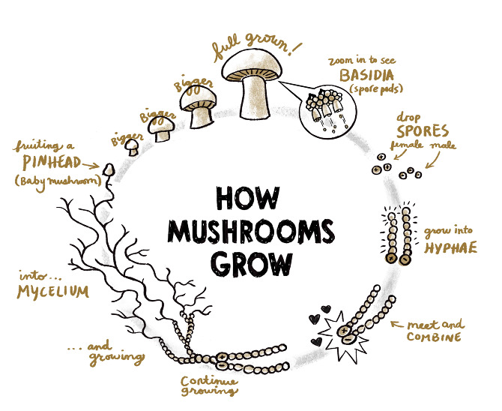

Fungus, like molds, has potential to be friend and foe. Fungus is a natural decomposer and gets rid of many unwanted things (like roadkill, fallen trees, and litter). This little guy, however, can also wreak havoc on human and animal health.

Assignment
Read one of the articles provided. Create a company recall letter that will be posted on the company’s website and sent to local news agencies for immediate publication. Use the information from the articles to guide you in writing this recall. A sample recall letter is also provided (this article is not related to fungi).

Be sure to create a company letterhead and use appropriate grammar and punctuation, since this is a formal document. Follow the rubric for better guidance and to achieve the score that you wish to attain.

Be sure to include in your letter:
- Company letterhead
- Company contact information
- Date
- Fungal toxin identified
- Audience that will be impacted
- Food(s) that are contasminated
- What to do with recalled product
- Signature Line

