Raised Bed Gardens: Straw Bales Garden, 7.00, P:1

Agriculture Literacy Strategy- Anticipation Guide

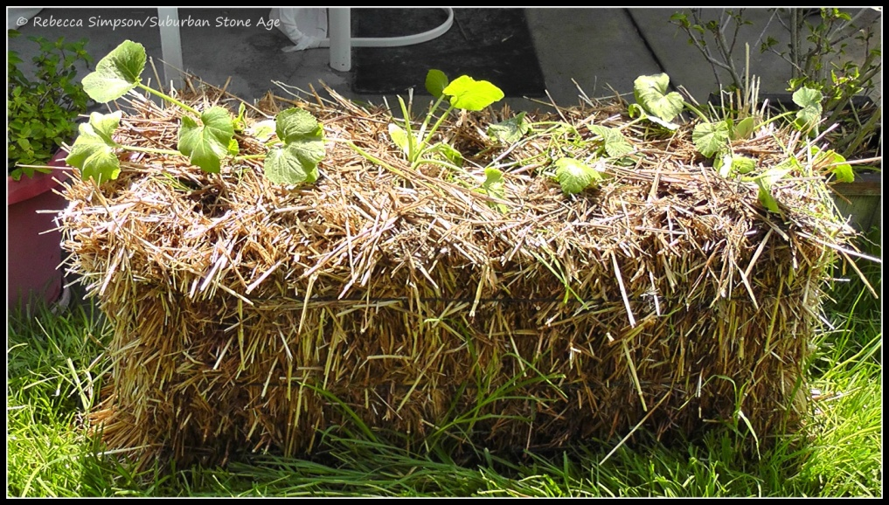

On your own: In the space to the left of each statement, place a T if you think the statement is true, an F if you think it is false.
In small groups: Compare your answers and discuss why you have agreed or disagreed with the statement.
On your own: Read my article entitled Straw Bale Gardening, marking the page number or other supporting evidence to confirm or refute your original prediction beside the statement.
In small groups: Defend your point of view—politely but firmly.
Whole group discussion: What are the benefits of using straw bale gardens and what are the disadvantages?

Before |  | After | Evidence
 | Straw bales are the same thing as hay bales.
 | Straw bale gardening is much more difficult than traditional gardening.
 | You can prepare straw bales for gardening just by watering them for three to four weeks prior to planting.
 | If you don’t want to use a high nitrogen fertilizer to get your bales cooking you can substitute with blood meal.
 | Watering straw bales after planting is not an issue or concern.
 | Once straw bales have been planted you will not need to fertilize the plants again.
 | In general, planting straw bales is much cheaper than traditional gardening.
 | Straw bale gardening is good for someone with back problems or someone who is disabled.
 | Straw bale gardening would be a good option for someone living in an apartment or condominium.

