Essential Elements Poster
You will be assigned one of the essential plant elements to create an informative poster. Create the poster using one of the computers in the back or a laptop. Use a WORD document or something similar. You will print the poster in color using the printer: 452.
Include the following information:
- Create a square with the atomic information- just like on the periodic table. (10pts)
  - What is the atomic symbol?
  - What is the name of the essential element?
  - What is the atomic weight?
  - Is this a liquid, solid, or gas?
- What does this element do for the plant and its functions? (5 pts)
- What symptoms will the plant exhibit if the element is unavailable (deficiency) or provided in too high of a quantity to the plant (toxicity)? (5 pts)
- What pH is this nutrient available and unavailable to the plant? Use the “soil pH availability chart” (5 pts)
- How could you ensure that this nutrient is available to the plant? (5 pts)
- Include two images (in color). (10 pts)
  - One image should exemplify the essential element.
  - One image should illustrate what happens to the plant if it is unavailable or toxic to the plant.
  - Provide captions explaining each image.
- Overall professionalism (10 pts)
Example:
Information about the element would be in this box.
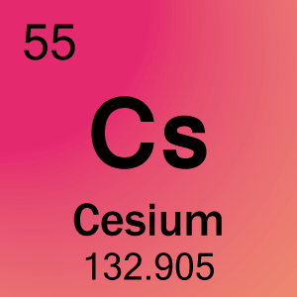
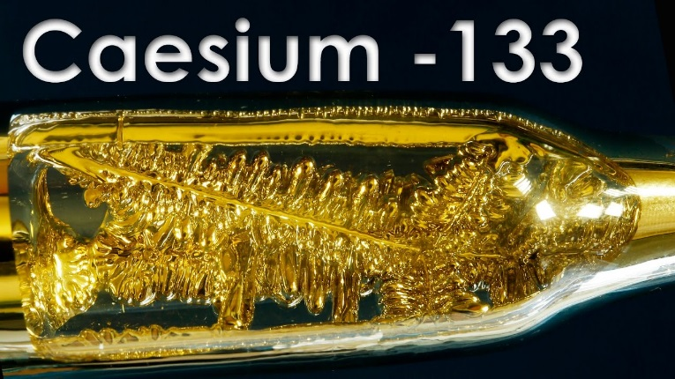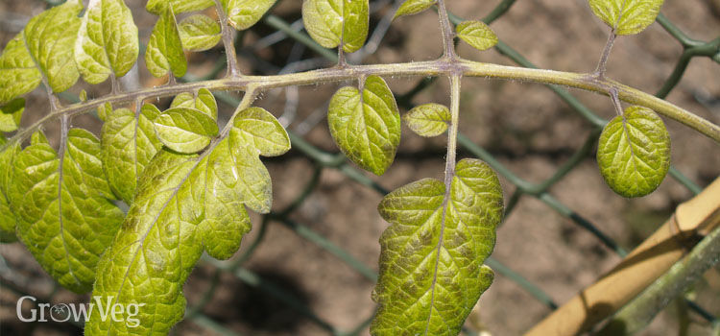
Here is where the captions would go for the images.

