HRT 1 Week 1 Perennials
Canna X generalis herbaceous  Common name: __________________________________  Hardiness zones: _________________________________  Size range: ______________________________________  Lear arrangement: ________________________________  Leaf composition: ________________________________  Leaf shape: ______________________________________  Notes: | 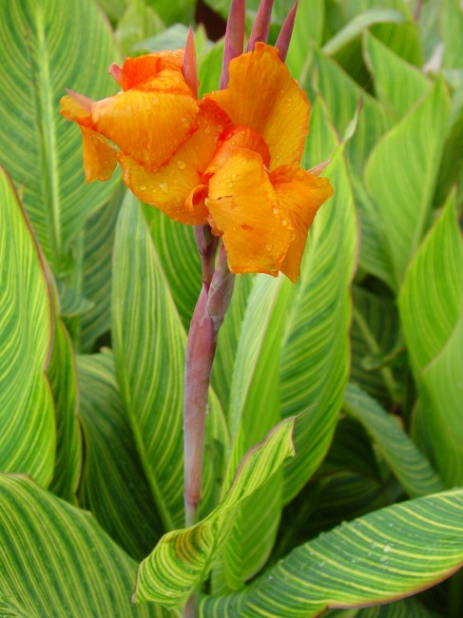
Chrysanthemum X superbum evergreen  Common name: __________________________________  Hardiness zones: _________________________________  Size range: ______________________________________  Lear arrangement: ________________________________  Leaf composition: ________________________________  Leaf shape: ______________________________________  Notes: | 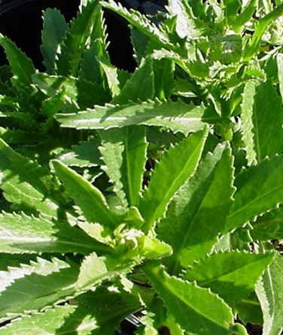
Chrysanthemum morifolium herbaceous  Common name: __________________________________  Hardiness zones: _________________________________  Size range: ______________________________________  Lear arrangement: ________________________________  Leaf composition: ________________________________  Leaf shape: ______________________________________  Notes: | 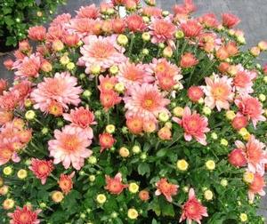
HRT 1 Week 1 Perennials
Hedera helix evergreen  Common name: __________________________________  Hardiness zones: _________________________________  Size range: ______________________________________  Lear arrangement: ________________________________  Leaf composition: ________________________________  Leaf shape: ______________________________________  Notes: | 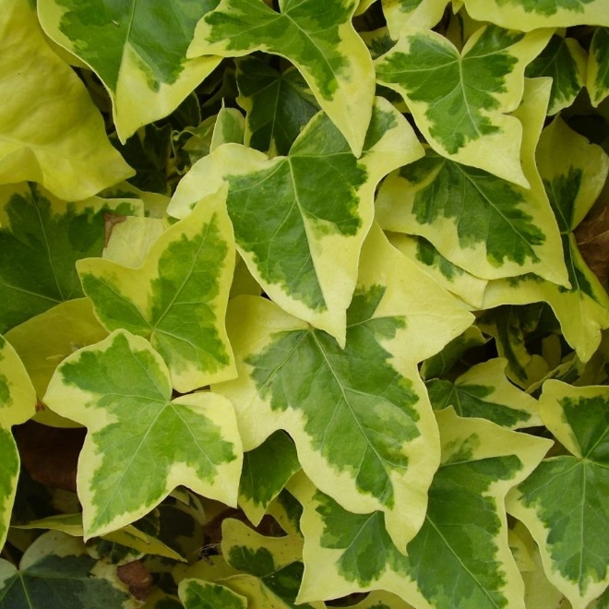
Hemerocallis herbaceous  Common name: __________________________________  Hardiness zones: _________________________________  Size range: ______________________________________  Lear arrangement: ________________________________  Leaf composition: ________________________________  Leaf shape: ______________________________________  Notes: | 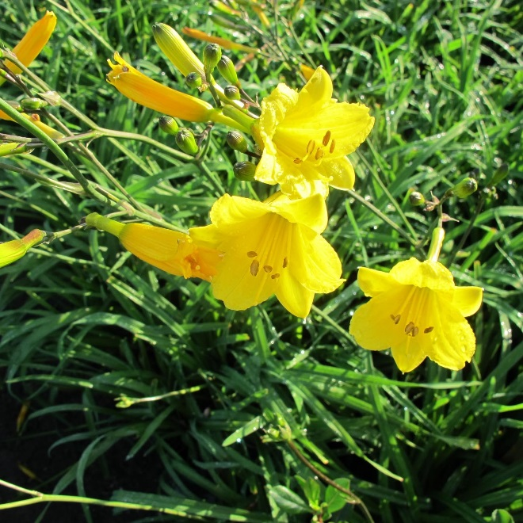
Hosta sp. herbaceous  Common name: __________________________________  Hardiness zones: _________________________________  Size range: ______________________________________  Lear arrangement: ________________________________  Leaf composition: ________________________________  Leaf shape: ______________________________________  Notes: | 