Just Eat It: Radishes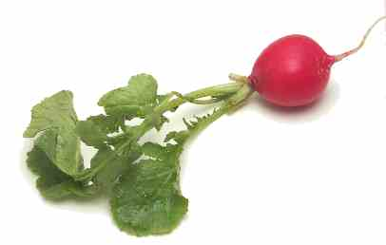
Investigate how a radish can improve your health, add nutrients to your meals and is a welcomed addition to nearly any course of any meal.
List 10 nutritional benefits of eating a ½ cup serving of radishes | 1. 6.  2. 7.  3. 8.  4. 9.  5. 10.
Describe how radishes can be eaten throughout the day. | Meal of the day An example of a dish for this meal using radish bulbs or greens  Breakfast  Lunch  Snack  Dinner
Include a recipe for an innovative dish using radishes. Include the nutritional information of the dish, if available.

