Nursery Structures Matching 3.01, P:1
Hot Bed
Cold Frame
PNP
Container
Field Grown
Winter Protection
1) Plants are easy to move and transport.
2) Grown to sellable size in the container.
3) Less shock to plants.
4) Retailers can keep plants longer before selling.
5) Uniform soilless media.
6) Insects, diseases, fertility and pH are easier to control.
7) Monitoring of water intake is easily controlled.
1) Requires more water.
2) More labor intensive.
3) May become pot bound.
4) May require winter protection.
5) May have a higher start-up cost pots, potting media.
6) Plants may have to be moved to a larger container.
7) May be expensive to ship.
1) No staking.  2) No blown over containers.  3) Cooler roots in the summer.  4) Well insulated root system in the winter.  5) Easy to move and transport.  6) Is becoming a more viable option to the traditional field grown.  7) Combines the benefits of field production with the marketing flexibility of container production.  1) Startup cost is expensive largely due to field preparation and purchasing two containers for every plant as opposed to one. 15-25 gallon pots are more commonly used.  2) Labor costs. |  | 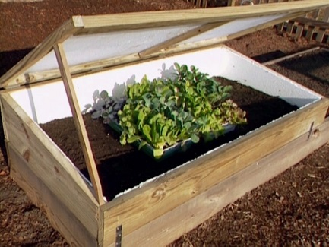
1) Plants are grown directly in native soil.  2) Bare root plants are easy to handle and plant.  1) Requires equipment to be harvested.  2) Plants may go into shock when moved or transplanted.  3) Harder to control insects, diseases, fertility and pH.  4) Soil must be well drained.  5) Limited time to harvest.  6) Supply cost, liners, supplies burlap, wire baskets, twine, and pinning nails.  7) Expensive shipping |  | 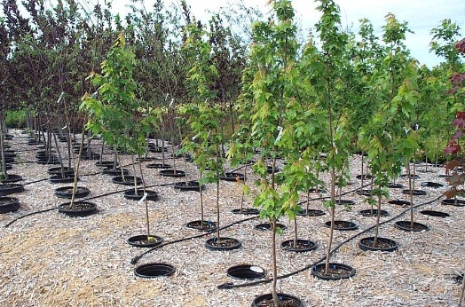
a. Need painting or replacing over time.  b. Plastic covering will need to be replaced on a regular basis.  c. Replacement of gravel and weed block.  d. Debris removal. |  | 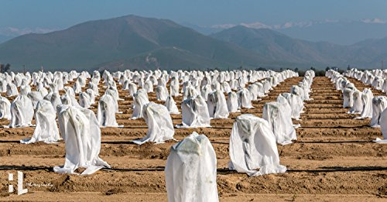
a. Change out heat source (straw, hay, manure).  b. Pest control.  c. Cover replacement.  d. Debris removal. |  | 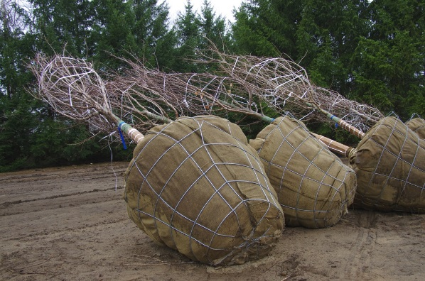
Frost blanket.  1) Traps and collects heat during the day and releases it at night to keep your plants warm and growing.  2) In the spring it gives you a jump-start on plants and wards off pests.  3) In fall, use it to extend your growing season.  4) Float or drape the lightweight fabric over your plants.  Water (bud protection).  1) Spray water on buds before a freeze.  2) Often used on fruit trees and strawberries.  White plastic.  1) Reduce overwintering injury to woody ornamentals.  2) Protects young plants in early spring. |  | 