Plant Morphology Stations, 3.03 P:1
Answer the questions listed for each of the following stations.
Station #1- African Violet (Saintpaulia ionantha)
- Describe the leaf margin.
- What is the vein pattern of the leaf?
- Is this a simple or compound leaf?
- What is the flower shape?
- This plant is hardy to zone ___. Would that be a perennial or an annual in Raleigh (what is its life cycle)? You will need to look this up if it is not on the tag.
Station #2- Fern (Nephrolepis exaltata)
- Is this a simple or compound leaf?
- What is the leaf arrangement?
- What is the shape of the leaves?
- If this is an annual here in Raleigh, and it is too cold here in the winter for this plant, what zone(s) do you think it will survive in? Hypothesize.
- What is the vein pattern of the leaves?
Station #3- Golden Pothos (Epipremnum aureum)
- What is the leaf shape?
- What is the vein pattern?
- What is the leaf margin?
- What is the leaf arrangement?
- What is the leaf surface?
Station #4- Iris (Iris X germanica)
- What is the vein pattern of the Iris?
- What is the shape of the leaf?
- What is the margin of the leaf?
- What is the stem modification of this plant?
- What is the shape of this flower?
Station #5- Leaf and/or Stem Modifications
- What is this leaf or stem modification?
- What is this leaf or stem modification?
- What is this leaf or stem modification?
- What is this leaf or stem modification?
- What is this leaf or stem modification?
USDA Hardiness Zones
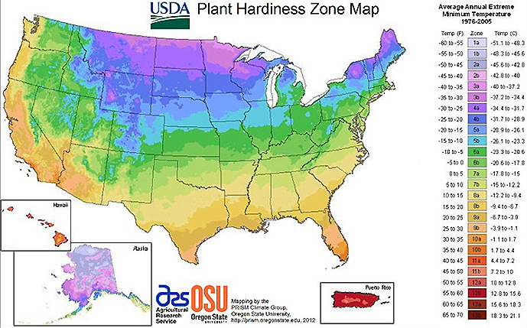
- There are ________ zones on the USDA Hardiness Zone Map.
- Each zone represents an area that shares the same average _____________ temperature.
- A plant’s hardiness is determined by what temperatures are best suited for its growth. When a plant is hardy to a particular zone or set of zones it has a _____________ life cycle there.
- If a plant is considered hardy in zones 13, what is the only place in the USA where it would be a perennial?
- If a plant is a perennial in zone 1, what is the only state where it would have a perennial life cycle?
- What are the three zones of North Carolina?
- What zone is Wilmington?
- What zone is Raleigh?
- What zone is Asheville?
- If geranium is hardy to a zone 9, would it be a perennial or an annual in Raleigh?

