Media, Soil, and Hydroponics Test Review 5.00
Turn in on the day of the test for 5 points on your test.

Basic Info on Soil and Media
- Once living material.

  - Vermiculite- inorganic, gold, holds water
  - Perlite- inorganic, white, drainage, volcanic rock
  - Bark- organic, drainage, weight in pots
  - Peat moss- organic, holds water
  - Moss- organic, holds water
  - Compost- organic, adds to structure of soil
  - Manure- organic, adds to structure of soil

- Never living

  - Vermiculite
  - Perlite
- Acidity and alkalinity, 1-14 (7 neutral)
- acid
- neutral
- it locks it up, makes it unavailable
- cover the soil with material (organic or inorganic)
- they allow the seeds to fall down in the pores and get lost or covered too deeply

Soil
- horizons

  - O- organic, humus
  - A-topsoil, rich in organic
  - B-subsoil, somewhat leached
  - C- bedrock

  - R- parent material, impermeable

- granular
- the way it feels
- prismatic, massive, or platy
- loose

  - Clayey- holds lots of water
  - Loamy- equal parts of sand, silt, and clay- BEST
  - Sandy- very little WHC
- Use soil sample and wet, squeeze into a ribbon, feel texture
- Soil triangle uses percentages (from soil distribution) to determine texture
- 50% solid, 25% water, 25% air
- How water and air move through soil and are held
- Better- add organic matter, rotate with fibrous crops, don’t till… worse- makes lots of trips in garden, work when it is wet, compact soil
- Small-clay, large-sand
- loam
- permeability

Soil Test
- see what nutrients you have in soil
- NCDA and CS, extension agent
- pint
- do not include in overall sample
- shovel, bucket, sample sheet, record of where taken, sample sheet from NCDA
- lawn 4”, other 6”
- spring
- keep a record
- application rate for correction
- ppm (parts per million)
- clay
- extension agent

Soil Triangle
See backside of sheet.

pH
- acidity and alkalinity
- 5.5-7
- Acidic= blue, alkaline= pink
- Add limestone
- sulfur
- 4
- pH must be correct or nutrients cannot be absorbed

Soil Textural Triangle

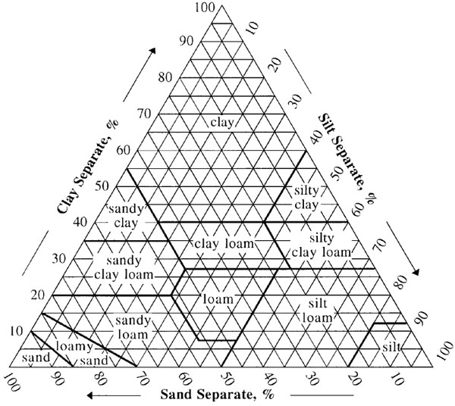

- Clay loam
- clay
- Sandy loam

