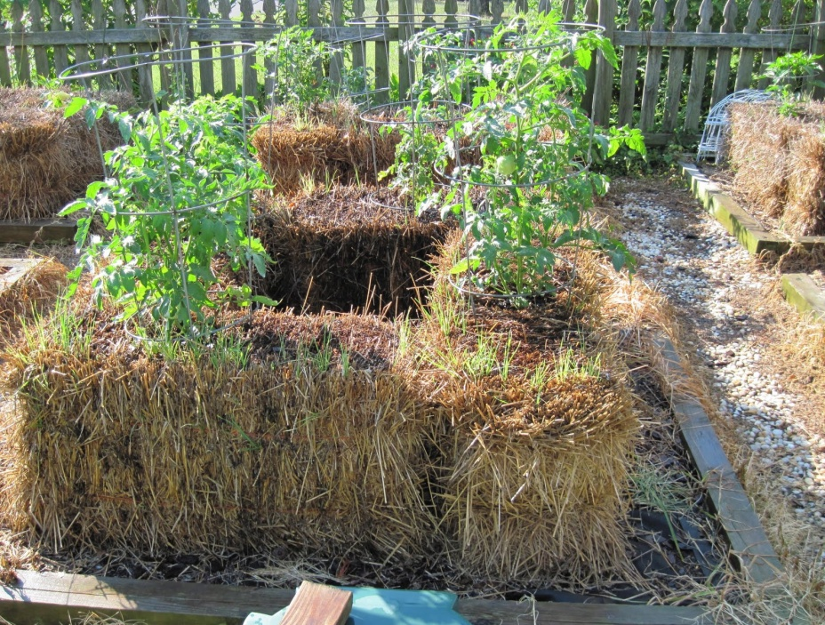

**Straw Bale Gardening**

**Do you have nasty soil?**

**Do you live in a place where you just**

**don’t have enough space for a garden?**

**Do you have difficulty stopping or**

**bending? Then Straw Bale Gardening**

**is the answer to growing your plants.**

This is the perfect way to garden sustainably and organically without having to do too much work. The method that we will discuss is for a four, stacked straw bale garden. With this method, you can grow a multitude of different plants and reap a harvest that will make many traditional gardeners envy.

**Getting Started**

You can go to any garden store or home repair shop to grab some straw bales. Wheat straw is a good choice for this area. Purchase four bales or one (if you want to start small). The four bales will be arranged to form a shape like a box. Once these are home, stack them in the following arrangement:   
Plan your spot carefully with full sun. Once the bales are placed, they are extremely heavy. Place the bales so that the twine is not showing from a bird’s eye view. I’ve never tried to weigh a soaking wet bale of straw, but that’s because I couldn’t even budge it to begin with. You’ll not want to change your mind and move things around.   
You can grow any vegetable, but remember you will need to stake those that grow tall. Try putting a vegetable that is tall in the center compost with something like a tomato cake or create a trellis for peas. You can plan on two to three tomato plants, four pepper or cucumber plants, or four to six lettuce plants per bale. Each vegetable usually requires one to two square feet per bale. Usually, the maximum planting is three plants per bale.

**Bale Preparation**

You’ll have to prepare the bales to make sure they’re past the initial heat of decomposing. With the proper fertilizers and water your straw bale should warm up to a temperature of about 100 degrees. As in many gardening techniques, there are proponents of several different methods. You can prepare your bales by just keeping them wet for three to four weeks prior to planting. If you prefer a more proactive approach, here’s one widely recommended method.  
Days 1-3: Water the bales thoroughly and keep them damp.  
Days 4-6: Sprinkle each bale with a 1/2 cup of a high nitrogen fertilizer like ammonium nitrate (34-0-0) or ammonium sulfate per day, and water it well into the bales. If you’d like you can substitute blood meal for the nitrate.  
Days 7-9: Cut back to 1/4 cup of fertilizer per bale per day, and continue to water it in well.  
Day 10: No more fertilizer, but continue to keep the bales damp.  
Day 11: Stick your hand into the bale. If it has cooled down to less than your body heat, you may safely begin planting as soon as all danger of frost has passed.

**Bale Cultivation**

Watering– You will most likely have to water every other day. A good idea is to get a soaker hose and loop that around the bales and in the center. As the bales continue to decompose, you should have to water less frequently.

Fertilizing- Once plants have been established for a couple weeks, it is great idea to start fertilizing again. You could just use the good old liquid feed like Miracle Gro (the blue stuff) or a slow release fertilizer like Osmocote. If you are an organic grower, try using compost tea or vermicompost.

**Bale Cultivation**

Watering– You will most likely have to water every other day. A good idea is to get a soaker hose and loop that around the bales and in the center. As the bales continue to decompose, you should have to water less frequently.

Fertilizing- Once plants have been established for a couple weeks, it is great idea to start fertilizing again. You could just use the good old liquid feed like Miracle Gro (the blue stuff) or a slow release fertilizer like Osmocote. If you are an organic grower, try using compost tea or vermicompost.