The Fascination with Fermentation
Wine and Beer Fermentation Observations and Questions: Use the following source.
http://www.nature.com/scitable/topicpage/yeast-fermentation-and-the-making-of-beer-14372813
Type these answers on a separate document.
- When were the first wines thought to have been made?
- Describe the first time someone might have been drunk and their hangover.
- Use this table to better understanding fermentation history.
Region/Country | Years | What were they fermenting?
 |  | Meade-honey wine
 |  | Chicha
 |  | Octli
 |  | Malted Barley

- Where does the word fermentation come from? How was this named derived- what observations were made?
- How do traditional wine makers transfer microorganisms into the wine making process?
- Define yeast.
- Describe the contributions of each of these scientists.
Scientists | Contributions to Common Understanding of Fermentation
Leeuwenhoek
Lavoisier
Gay-Lussac
Cagniard
Pasteur
Bigo
Buchner
Karl Lohmann, Yellapragada Subbarao, and Cirus Friske
Lipmann
- What are ALL of the products or components that go into the process of fermentation?
- Fermentation is a __________________ of yeast multiplication. The yeast have to be ____________ for alcohol to be produced.
- What is the difference between alcoholic and lactic acid fermentation? Why did the beets used by Bigo not produce fine brew?
- What is glycolysis?
- When and why did glycolysis evolve?
- What is glucose converted into during glycolysis?
- What two routes can pyruvic acid take?
- What are the two byproducts of fermentation?
- Which byproduct are we most concerned with in our food science courses? Why?
- What does the accumulation of alcohol do to the yeast cells?
- How are wine and beer alcohols produced differently than liquors?
- How is fermentation so essential for the agriculture and food science industries?
- Rewrite the summary in your own words, in three sentences.
Microbial Fermentations: Use the following source.
http://www.accessexcellence.org/LC/SS/ferm_background.php
- Three ways fermentation is important in our lives:

- Fermentation is the process that produces ____________________ beverages or acidic _________________ products. In general, fermentation involves the breaking down of complex _________________ substances into simpler ones.
- What are the four substances produced as waste products from the fermentation process that we use in our everyday lives and industry?

4.How are lactic acid and alcohol fermentation alike and different?
Differences
5. How could industry use microbial fermentation to alleviate its dependence on petroleum?

6. How could plant starches, cellulose from agricultural waste, and whey (a byproduct from cheese manufacturing) be problematic for the environment but a potential benefit, as well?

7. Describe what this bioreactor does and list three products created by an industrial bioreactor.
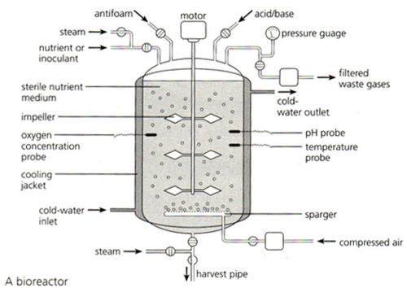

8. What was the greatest factor (historically) in the development of synthetic rubber?

9. Why did the British government need a high yield of butyl alcohol and acetone?

10. What crops were fermented to produce butyl alcohol and acetone?

Extra somethin’ something’:
*After WWI, what did the British Prime Minister find that Weizmann wanted for a reward for his scientific (fermentation) contributions to the war effort?

*Ultimately, what notable position did this microbiologist undertake in 1949?

